floor and we applied the same logic. We divided the whole bridge into four parts i.e. four strips. Two constant strips that would make the two end parts of bridge and two bascule parts that form the remaining middle position of the bridge.

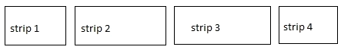

Fig 6.1 Designing strips by using rectangle

Since we designed all the four strips separate it helped us to lift the two bascules easily because we need not to lift other two strips.

Our next part was to design the poles at the two ends of strip 2 and strip 3. After we designed the water body and the bridge, we never felt difficulty of designing these four poles.



Fig 6.2 Pole of Bridge using two straight lines

Our next part was to connect the intersecting end of the bascules to the top of tower by drawing the straight between those two. We designed four straight lines for this purpose. We designed these four heavy cables that are used to lift up the heavy spans using the counterweight principle.

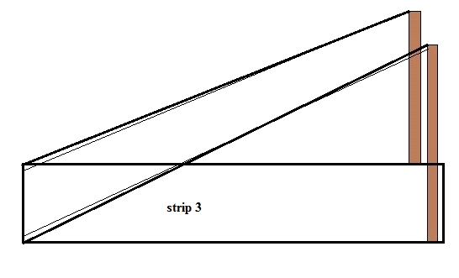

Fig 6.3 The design of Bascule